1. **Hello World Program**: Write a Java program that prints "Hello World!!" to the console.

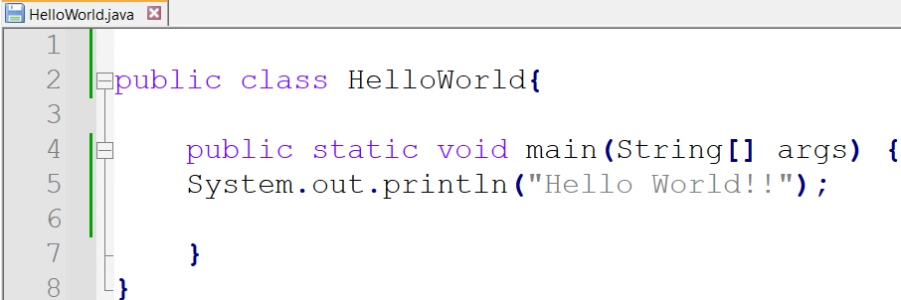

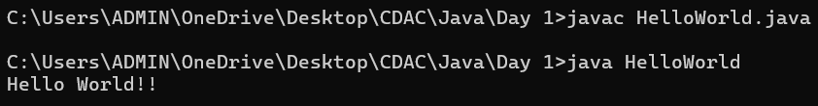

1. **Compile with Verbose Option**: Compile your Java file using the -verbose option with javac. Check the output.

**-verbose** option while using javac shows information about all the predefined classes which got loaded during the compilation.

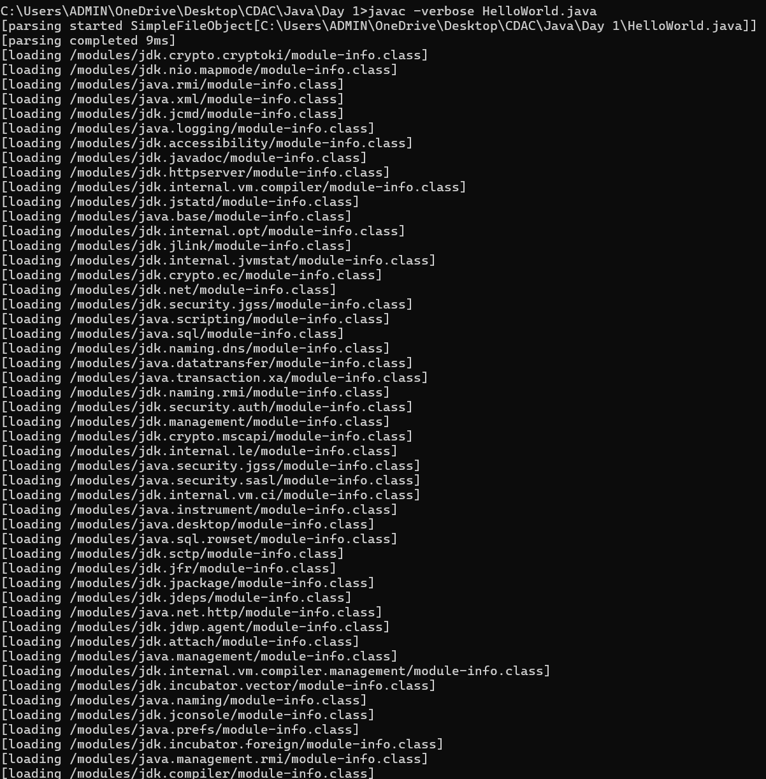

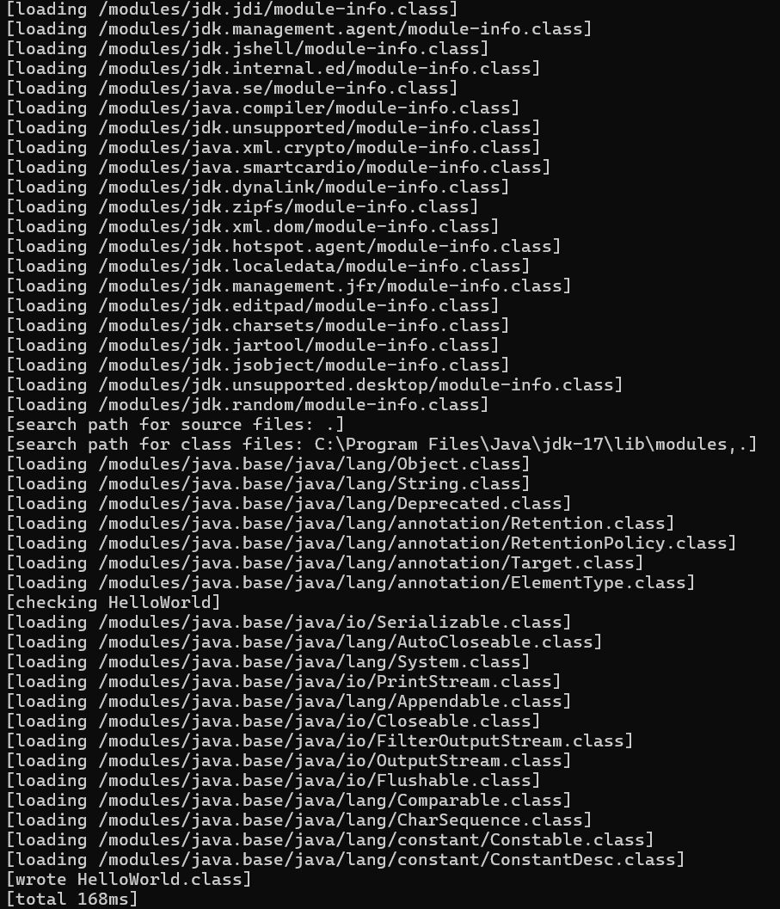

1. **Inspect Bytecode**: Use the javap tool to examine the bytecode of the compiled .class file. Observe the output.

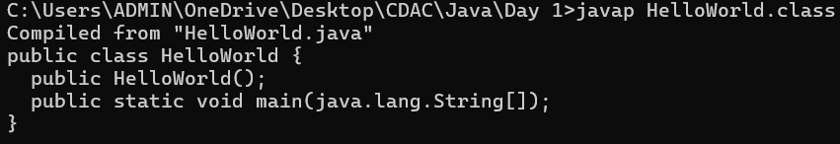

javap along with -c option is used to disassemble and display the byte code from the .class file

